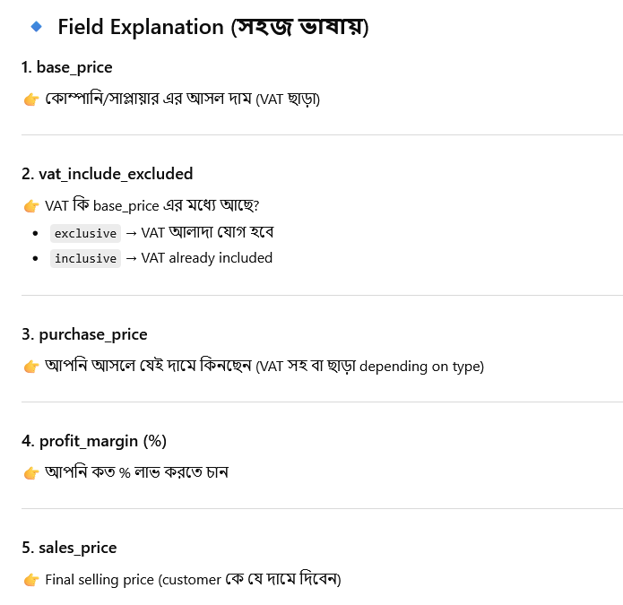
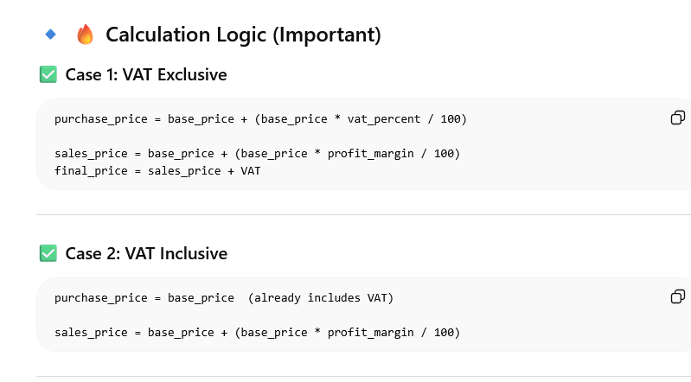
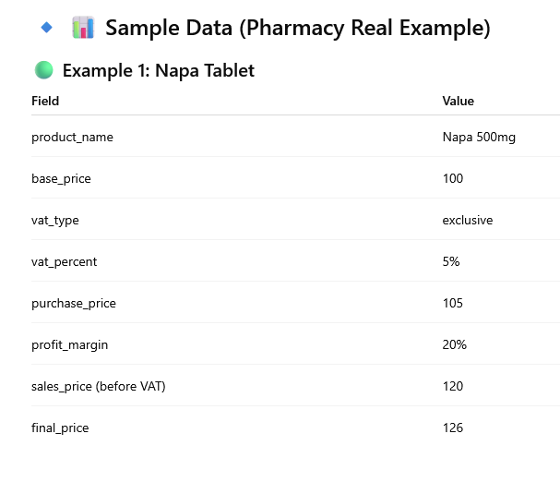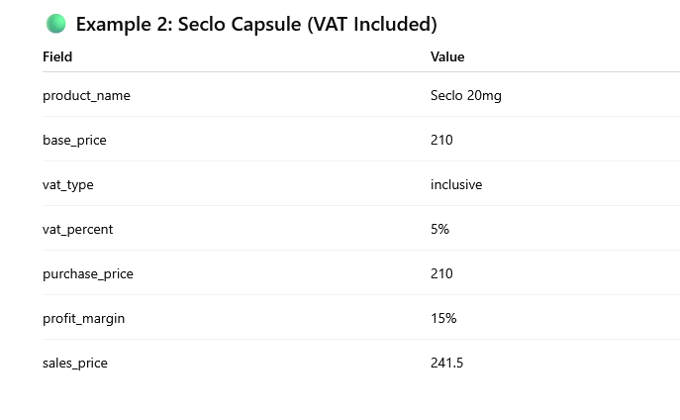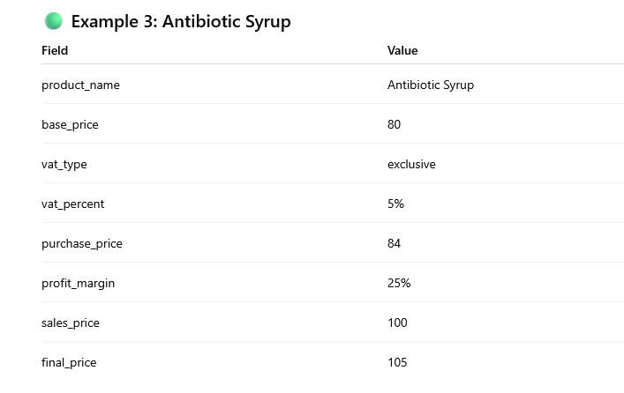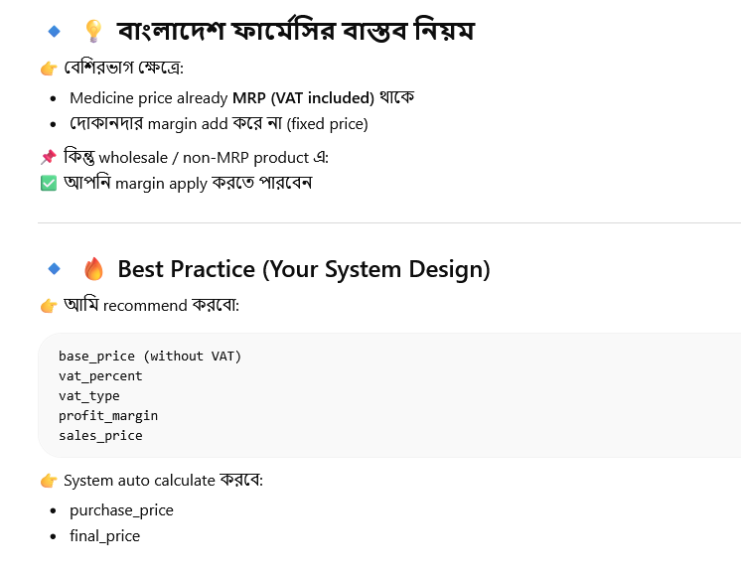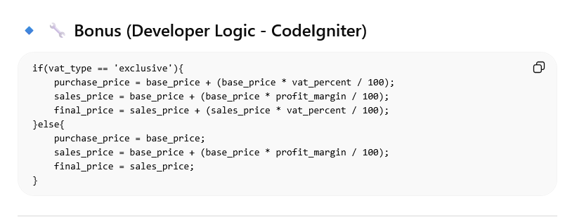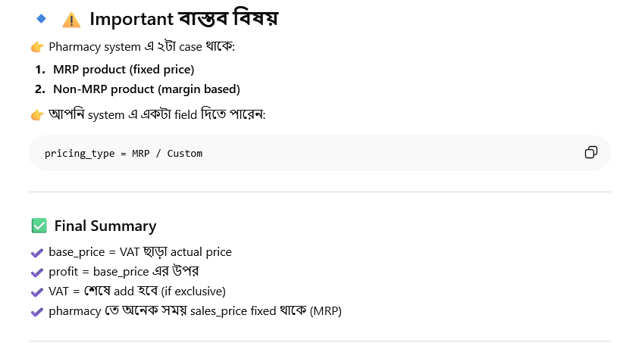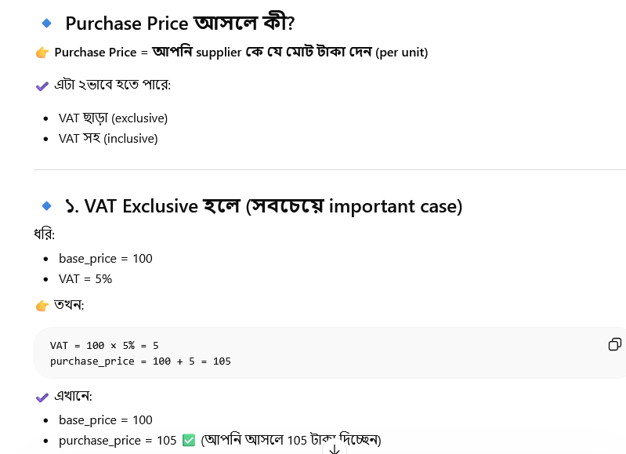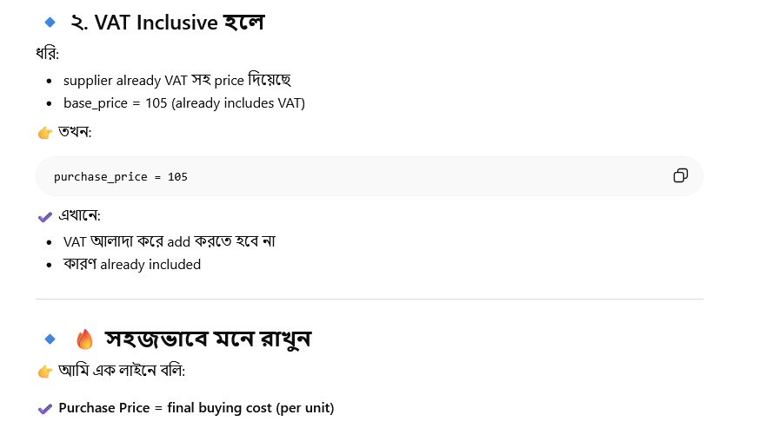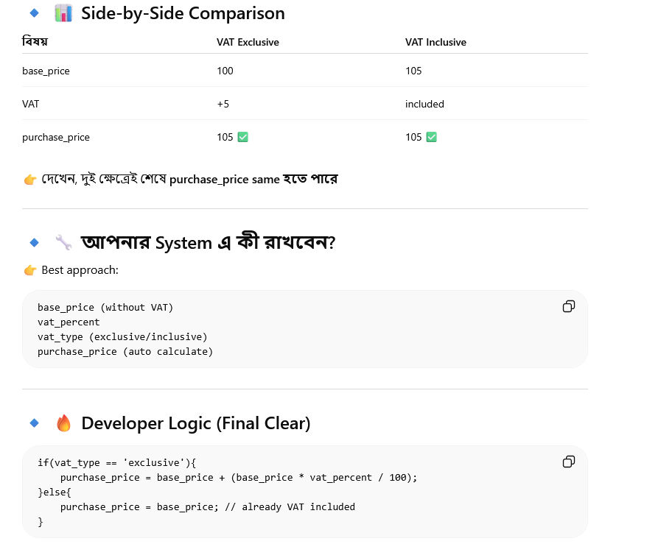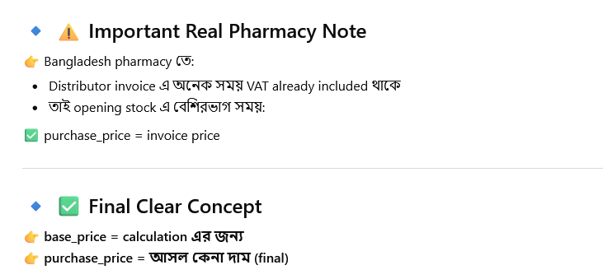
Pharmacy Opening Stock Sample Data
Product Name |  | Base Price |  | VAT Type | VAT % | Purchase Price |  | Profit Margin % |  | Cost without VAT |  | Sales Price (before VAT) |  | VAT on Sales |  | Final Price (Customer Pays)
Napa 500mg |  | 100 |  | exclusive | 5 | 105 |  | 20 |  | 100 |  | 120 |  | 6 |  | 126
Seclo 20mg |  | 210 |  | inclusive | 5 | 210 |  | 15 |  | 200 |  | 230 |  | 11.5 |  | 241.5
Antibiotic Syrup |  | 80 |  | exclusive | 5 | 84 |  | 25 |  | 80 |  | 100 |  | 5 |  | 105
Paracetamol 500mg |  | 50 |  | inclusive | 5 | 50 |  | 10 |  | 47.62 |  | 52.38 |  | 2.62 |  | 55
Vitamin C 500mg |  | 120 |  | exclusive | 5 | 126 |  | 30 |  | 120 |  | 156 |  | 7.8 |  | 163.8
Cough Syrup 100ml | 75 |  | inclusive |  | 5 |  | 75 |  | 20 |  | 71.43 |  | 85.72 |  | 4.28 |  | 90

1️⃣ VAT Exclusive
VAT_amount = base_price * vat_percent / 100
purchase_price = base_price + VAT_amount
Cost_without_VAT = base_price
Sales_price = Cost_without_VAT * (1 + profit_margin/100)
VAT_on_sales = Sales_price * vat_percent / 100
Final_price = Sales_price + VAT_on_sales

2️⃣ VAT Inclusive
VAT_amount = base_price * vat_percent / (100 + vat_percent)
Cost_without_VAT = base_price - VAT_amount
Sales_price = Cost_without_VAT * (1 + profit_margin/100)
VAT_on_sales = Sales_price * vat_percent / 100
Final_price = Sales_price + VAT_on_sales
purchase_price = base_price

3️⃣ Notes / Rules
- Profit always calculate on VAT excluded base
- Purchase Price = supplier invoice price
- Final Price = Sales Price + VAT (if VAT exclusive)
- VAT inclusive products → extract VAT from base_price using reverse calculation

